Instructional Design Model | For Editing by Content
Great Minds' Bird's Eye View product vision centers on two things: students engaging in grade-level content and teachers doing the work only teachers can do. Students experience themselves as capable mathematicians, building confidence through consistent routines, learning that is intentionally designed to reflect the needs of the content, and consolidating understanding in their own words. Discourse is central: students justify their reasoning, compare strategies, build on each other's ideas, and engage in the kind of mathematical exchange that deepens understanding. Teachers make that possible by doing the work only teachers can do: building relationships, providing explicit instruction, facilitating discourse, developing mathematical identity, and managing the conditions of a productive classroom.

Strawman 2.0 surfaced a real problem: teachers are overwhelmed. Strawman 4.0 responds by supporting teacher responsibility for skill-building, practice management, and feedback delivery with the product, freeing teachers to focus on that irreplaceable human work. It also provides specific, explicit support for teachers in areas confirmed by Strawman 2.0 to be troublesome: routine fidelity, pacing, and responding to data. The result is a lesson structure built around three components: Warm Up, Learning, and Practice, with titles that will likely evolve before final format.
Lesson Structure
This three-component structure is suggested as the core lesson structure. After the class is fluent in this base structure, we can add a novel structure with proper onboarding and consistency at the topic level, keeping in mind the cost of transitions.
- Warm Up refers to the first 5 minutes of a lesson. Warm up generally activates prior knowledge and builds procedural skill through immediate feedback (Building Mathematics Fluency, 2026, p 6). This component motivates mathematical thinking, offers a point of success for learners, and provides a window into student thinking (Deans for Impact 2016, 9). Non-digital delivery also creates a shared whole-class experience that strengthens mathematical community. Typical formats include choral response, whiteboard exchange, and sprint-based routines. To serve purposes outside of fluency, application problems and digital experiences (G3+) are available when transition costs are minimized. (Building Mathematics Fluency 2026, p.13-15)
- Learning builds on previous learning and introduces new concepts through an intentional sequence of activities facilitated by the teacher (Sutherland et. al. 2020, 73). Students work collaboratively with peers and the teacher to build knowledge through explicit instruction, structured discourse routines, guided exploration, visible mathematics, and methodical problem solving (Learning Science 2025, 11-13). Natural checkpoints provide opportunities for formative assessment, feedback, and error correction (Coe & Cole 2026, 19-21). Students summarize and internalize the big ideas of the learning before moving to independent practice.
- Practice gives students an opportunity to apply and refine mathematical procedures and reasoning. It is designed to build accuracy, retention, and the ability to transfer skills to new problems (Deans for Impact 2016, 7). Students work independently or with peers to solve problems, discuss thinking, and share solution strategies. Students receive feedback, delivered digitally or by the teacher, and use the feedback to address misconceptions and refine their approach (What Makes Practice Work? 2025, p. 3-6). The teacher circulates, observes, and attends to individual students throughout, capturing evidence of student understanding and delivering targeted feedback based on their thinking. Using this evidence, alongside data from prior lessons and embedded supports, the teacher decides whether to facilitate small-group instruction or adjust pacing (Curriculum Design Memo, 2025, p. 7).
This structure operationalizes the Bird's Eye View future vision of activating prior knowledge, understanding new content through activities and discourse, and working through a set of practice problems to receive feedback.
Miro (Lesson Structure Draft)
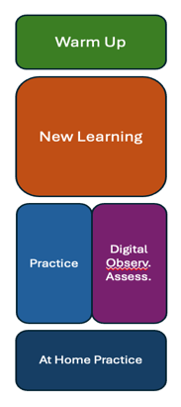
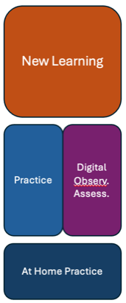
Core Lesson Structure PK/TK Core Lesson Structure K-9

Novelty Lesson Structure: These components can be used as needed and can be shuffled to meet the needs of the content, with proper onboarding and consistency at the topic level, keeping in mind the cost of transitions. In addition, regardless of structural choice, summarization is included in every lesson at the end of the learning component, where it occurs, and at the end of the day’s lesson.
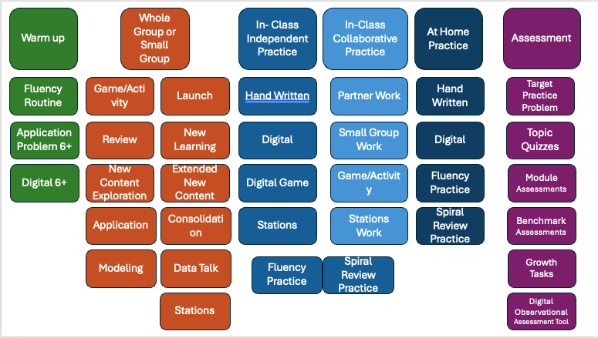
Lesson Experience Map:
While each lesson includes three components (warm up, learning, and practice) the order can vary based on the content, but consistency within a topic matters. Students build confidence and engagement when they know what to expect.
Key:
K-2 Only, 3-5 Only, K-5 Band, 3+ Only, 6+ Only, All Grades
*Indicates areas not supported by strong research. Our recommendation is to either conduct research, or move forward understanding the recommendation is based on a strong assumption.
Lesson Component | Student Experience | Options  Let the content drive the decision | Teacher Experience
Warm-Up  Research:  Rec. Doc  Lit Review | Build Readiness  Gain mathematical confidence by participating in a consistent routine across a topic where prior knowledge is activated.  K-5: Build foundational number sense and fact automaticity.  Feel belonging through whole group or partner activities.  Receive immediate feedback from teacher. Peer feedback such as a partner check or think-before-respond activity is appropriate in 3-5 with sentence stems for agreement or disagreement integrated.*  Connect the exercise to the learning, especially explicitly in grades 3-5.  In grades 6+ variety may serve a function similar to interleaving, introducing variety in warmup format is strongest here.  When included in the lesson, the component is required and included in the lesson timing. | Routine  Consistent process used to increase fluency. Especially important in K-5 but some applications appropriate in 6+.  Examples: Choral Response, Whiteboard Exchange, Sprint, etc. | Assess Readiness  Gain confidence in implementing a routine.  Observe students before instruction begins. Read the room, notice who is settled, who needs connection, and what the class needs to be ready to think.*  Create the conditions for a successful lesson.*  Choice  In K-2 highly specified materials with minimal teacher choice are most appropriate.  In 3-5 progressive disclosure can be implemented, teachers who have successfully implemented warm up routines across several topics may benefit from limited choice among 2-3 warm up types matched to specific purposes.  In 6+ teacher choice is most appropriate. Teachers at these grades make more frequent decisions about how warmup routines fit into their instruction
Digital Warm Up 3+
May appropriately replace whole-class formats on some days. The distributed practice evidence supports maintaining frequency even as format varies. Digital tools can provide the volume and personalization that a whole-class routines cannot. The transition costs must be minimized.
Application Problem, 6+ only
A utilization of previous learning to a novel situation.*
Example: Topic where word problems are especially prevalent.

Lesson Component | Student Experience | Modality Options  For Writers to Use, Not Named for User | Teacher Experience
Learning  Discourse Rec. Doc  Discourse Lit Review1  Discourse Lit Review 2 | Engage in New Content  Participate in a structured activity: partner task, group problem, or teacher-led experience.  Ground the learning in doing before defining.  Record learning using graphic organizers and age-appropriate note-taking tools.* | For Brand New Learning:  Launch Activity  A hook for new learning. Examples: Day 0, Launch into a project, Launch into deep problem-solving  Whole Group  Direct instruction; the teacher models thinking, demonstrates procedures, and guides students through examples. Asks students to replicate the work shown.  Exploration  Investigate a concept, pattern, or problem before receiving direct instruction. Asks students what they notice, and what might be true.  For Broadening New Learning:  Collaboration  Working together toward a learning goal. Asks students to work together to come to a consensus.  Examples: Partner work, small group work, games, Stations  Application  Use known mathematics to solve problems in a new context. Asks students to use what they know to solve the problem.  Modeling  Formal process in which students encounter a mathematical situation, make observations, test ideas, and draw conclusions. Asks students what math fits the situation.  For Summarizing Learning:  Consolidation  Solidify understanding by connecting ideas, refining strategies, and moving toward fluency or generalization. | Primary Focuses:  Conduct Explicit Instruction  Make decisions in real time. Name strategies, clarify misconceptions, give language to what students are discovering.  Facilitate Discourse  Lead structured discourse routines, using talk moves to surface and extend student thinking without taking over. Use embedded anticipated student responses and if-then decision trees to navigate misconceptions and keep discourse moving forward.  Assessment  Capture evidence of student mathematical understanding as it naturally emerges across the lesson by using the Digital Observational Assessment tool. Informal observations during instruction and results of student practice informs actionable teacher moves and feedback.  Develop Student Identity  Make deliberate choices about whose thinking is elevated, who is called on, how errors are framed. Build learner confidence and belonging. Celebrate mathematical risk-taking. Normalize productive struggle.
Discuss Understanding (required)
Read a problem and converse to surface strategies, reveal reasoning, and build shared understanding to work toward a solution.

Listen to and discuss thinking with peers and the teacher.

Write an explanation showing the reasoning behind the solution.
 | Analyze Work  Examine work samples: correct solutions, partial solutions, or errors.  Sharpen understanding.  Build the habit of looking closely at their own work. |  | Secondary Focuses:  Build Relationships  Know every student as a unique learner. Use moments of struggle and success to connect. Notice who is disengaged, needs encouragement, is ready to be pushed further.  Promote Positive Classroom Atmosphere  Oversee norms, safety, pacing, and transitions. Build and protect the conditions that make productive discourse possible.
 | Summarize (required)  Consolidate learning in their own words.  Name what was discovered, clarify misconceptions, and carry the key ideas forward into practice.  This could happen at the end of learning and also at the end of the lesson (typically after practice). | Naming the Learning  A structured opportunity for students to articulate the core mathematical idea from the lesson in their own words. For example, the students articulate the big idea to a partner before the teacher names it. Today I discovered… One thing I now understand is…  Checking for Misconceptions  A brief, low-stakes opportunity to surface and correct errors in understanding before students carry them forward.  Transfer Setup  A forward-looking reflection that connects today’s learning to upcoming work or broader mathematical thinking. For example, “Where do you think we’ll use this next?” “How does this change how you thing about ___?” | Stamp Big Ideas  Make learning visible and meaningful by guiding students to consolidate the learning.

Lesson Component | Student Experience | Modality Options | Teacher Experience
In-Class Practice  Practice Rec. Doc  Lit Review1  Lit Review2 | Independent or Collaborative Practice  Complete practice during class by themselves, with a partner, or with a small group.  Complete a Target Problem for an integrated assessment experience that is invisible to the student as a separate task. | Hand-Written  Practice completed by hand.  Digital Practice  Practice completed on a device.  Stations  Practice completed in small group activities. Students rotate through activities.  Instructional Routine (Activities)  Practice completed in pairs or small groups which could also include routines, such as card sorts, any of the math language routines, and other activities. | Component-specific small-group instruction  Conduct small group instruction, practice the same content in place of the digital experience. This allows for immediate feedback and closer observation of student thinking.
 | Each Practice set will include Lesson Practice and may include Spiral Review.  Lesson Practice  Immediate, targeted practice of newly learned concepts and skills. A Target Problem will be part of nearly all practice sets for teachers to check for learning acquisition.  Spiral Review  Distributed practice of each concept and skill that continues for one or more years. Early on, the time between practice sessions is short, with lots of practice in the first few days and weeks. The time gradually transitions to longer and longer spans between sessions. Spiral review may include skill or application practice.  (What Makes Practice Work, 2025, p. 3-6) |  | Observe and Monitor Progress  Spot patterns, note misconceptions, identify students who need support. Capture evidence of student mathematical understanding as it naturally emerges through DOARS tool. Informal observations during instruction and student practice allows the teacher to make informed decisions and actionable teacher moves.  Feedback  Deliver timely, targeted feedback to address misconceptions and refine student thinking. Materials support this with common misconceptions and if-then decision trees, so the teacher isn't building this guidance from scratch in the moment. Deans for Impact 2016, 6).
 | For more details, please visit Practice Rec. Doc. |  | Adjust Pacing  Read the room and feel empowered to modify timeframe or task if further instruction or extension are needed.
Out-of-Class Practice | Each Practice set will include Lesson Practice and may include Spiral Review.  Lesson Practice  Immediate, targeted practice of newly learned concepts and skills. A Target Problem will be part of nearly all practice sets for teachers to check for learning acquisition.  Spiral Review  Distributed practice of each concept and skill that continues for one or more years. Early on, the time between practice sessions is short, with lots of practice in the first few days and weeks. The time gradually transitions to longer and longer spans between sessions. Spiral review may include skill or application practice.  PK-GK  Lesson Practice activities sent home by module to be done with parents.  G1-G2  Fluency and Lesson Practice.  G3-Alebra 1  Fluency, Lesson and Spiral | Hand-Written  Practice completed by hand.  Digital Practice  Practice completed on a device. | Progress Monitor  Spot patterns, note misconceptions, identify students who need support, make informed decisions before moving forward.

Topic Structure
This topic structure diagram shows how a standard Strawman 4.0 topic could be designed. Structured through learning ladders, each topic could include an onboarding lesson, lessons for instruction, intervention, consolidation, or assessment. While lessons are numbered, the specific number of days per topic will depend entirely on the content. These components can be used as needed and can be shuffled to meet the needs of the content, with proper onboarding and consistency at the topic level, keeping in mind the cost of transitions.
- Diagnostic Assessment: Diagnostic assessment is suggested when a significant content shift occurs and previous data can't support next steps. Results guide teachers to deliver onboarding to the whole class, a small group, or skip it entirely. Teachers need a suggested success threshold, though this requires further research. The diagnostic assessment could also surface misconceptions that don't need a full lesson but can inform subsequent decisions, and identify intervention needs across the topic sequence for individuals and small groups. A digital diagnostic is not recommended below grade 3, however an AI tool, like Coteach, could be used by the teacher to aid in these decisions at all grades.
  - Student Experience: Students encounter a short, low-stakes check-in rather than a scored test preferably added to practice or another assessment experience so it doesn’t feel like another test. Depending on the results, they either move straight into the topic or get a bit of extra support first, so the diagnostic feels like a starting point, not a gate.
- Onboarding: Activates previous knowledge to prepare for upcoming content and introduces the warm-up routine if it's new to the grade. Could provide catch-up time for students who need it and allow for intervention needs. If assessment data shows whole group support isn't needed, the onboarding lesson could offer independent fluency or spiral review practice and small-group instruction for those requiring additional support, or it could provide a hook for students to want to learn more about the topic’s content.
  - Student Experience: Students start the topic together, reactivating what they already know and, if needed, learning a new warm-up routine alongside the rest of the class. From there, the lesson can go a few directions depending on what the data shows: some students move into independent practice while others get small-group catch-up time, or the whole class gets drawn into an experience that builds curiosity about what's coming, so onboarding meets students where they are instead of following one fixed path.
- Body of Learning: A consistent lesson structure with daily warm-ups keeps the focus on learning. Each day targets a specific conceptual and/or procedural focus. Targeting different parts of the topic across days builds conceptual coherence, procedural fluency, and conceptual understanding; multiple days of practice strengthen all three.
  - Student Experience: Students feel the steady build of the content, one focus per day, but the routines stay familiar even as the content shifts. Students share problem-solving strategies with partners, analyze student work, and learn from mistakes, with most of the learning happening through discourse routines predictable enough to feel comfortable rather than effortful.
- Intervention/Flex lesson Students begin with different levels of prior understanding, requiring differentiated time and support. A flexible structure allows an additional day of targeted practice when needed, letting teachers respond to real-time student challenges and misconceptions. Informed by formative data, this lesson can include interleaved practice, small-group or individualized instruction, or more challenging problems.
  - Student Experience: Students who need more time get a dedicated day to work through misconceptions before moving forward, instead of a rushed catch-up squeezed into the next lesson. Students who've already got the new content move into more challenging problems or interleaved practice that mixes in earlier topics, so they're extending their thinking rather than sitting through material they've already mastered.
- Consolidation: This lesson provides opportunities for students to make connections between the big ideas of the topic. After learning topic content, students need dedicated time to consolidate what they have learned across the topic with additional review and practice. Making explicit connections to prior topics strengthens coherence and supports long-term retention. This lesson could engage students in synthesis tasks, cumulative practice problems, and reflection on learning across the topic, with discourse around big ideas as the primary means of consolidating understanding.
  - Student Experience: Students get dedicated time to step back, connect ideas across the whole topic, and see how the pieces fit together, rather than moving straight from the last new concept into an assessment.
- Assessment: This day formalizes the assessment of concepts, confirming what teachers have already observed during instruction with use of the Digital Observational Assessment tool. Assessments are not intended to introduce new instructional decisions, but to confirm and document what teachers have already learned through instruction and observation. Rather than anchoring to fixed schedules, assessment timing ties to meaningful moments in the learning progression, conceptual shifts, and instructional opportunity points where students are expected to make meaningful reasoning shifts. If a topic assessment does not fill an entire period, the remainder goes to fluency and spiral review practice. Blocked practice may support initial fluency for novices, but interleaving is consistently more effective for consolidation and transfer.
  - Student Experience: For students, this feels like a continuation of what they’ve been doing all topic, not a surprise or a high-pressure event, since it mostly confirms what the teacher has already observed.

- Respond to Assessment: Because not all mathematics requires the same depth of learning, the response to assessment data should match what each target actually demands. These identifications in the knowledge graph aid in determining locations for assessment opportunities, including diagnostic assessments.
    - Mathematics that future learning depends on warrants reengagement when most students aren't there yet.
    - Mathematics where supported, accurate use is the goal only requires that students can use it well enough for its purpose.
    - The mathematics that students are meant to encounter rather than master should never become a gate for moving forward.

  - Student Experience: Students spend extra time only on the math that matters most for what's next. They aren't held up on ideas they were only meant to encounter, not master.

Core Topic Structure All Grades
*Fluency and Spiral Review practice after assessment is especially important if practice is first in the lesson structure because there will be no organizational place for it in the daily in-class practice set.
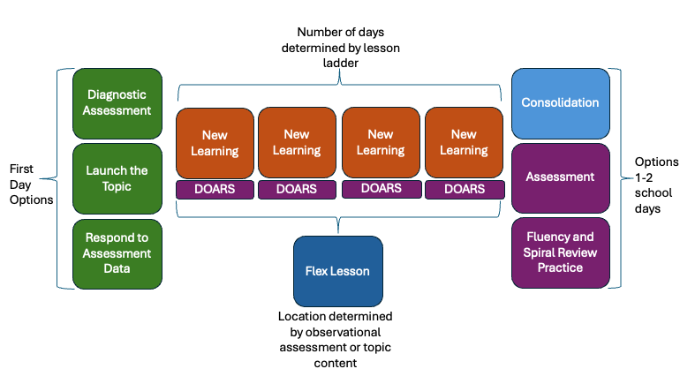

Example Module Structure
This module structure diagram shows how the nodes Number Systems and Structures: Fractions and Operations and Equations: Addition and Subtraction could be designed for Grade 4. Structured through learning ladders, each module could include lessons for onboarding, launching new content, learning, intervention, or consolidation. They could also include moments to respond to assessment data, provide small group instruction, diagnostically assess student learning, assess learning, and provide opportunities for fluency and spiral review.
Across the module, students move through a mix of new learning, practice, and review that adjusts based on how they’re doing, so the structure feels responsive to them rather than a fixed march through content.
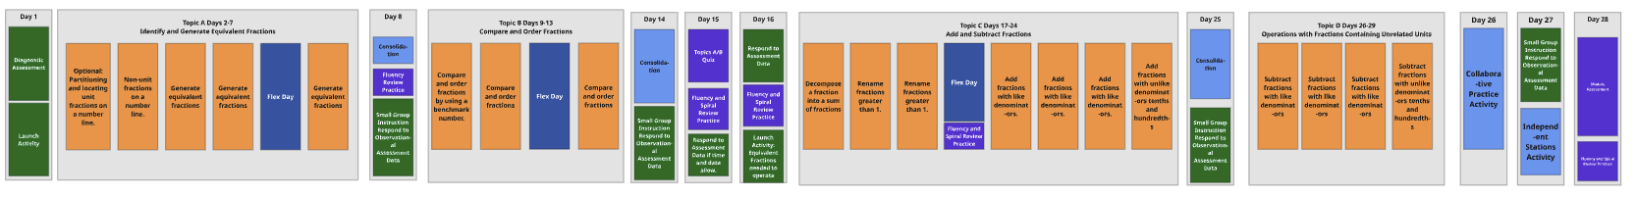
Image found at bottom of Practice Miro Board https://miro.com/app/board/uXjVHJrZiqA=/

Validation Signals in Strawman 4.0
Several recommendations above are marked as not yet supported by strong research (*) or flagged as needing further testing. The signals below turn those flagged assumptions into things to actually check in Strawman 4.0.
- Do teacher’s "read the room" practices before Warm Up measurably affect lesson readiness or pacing? (observation protocol, teacher confidence survey)
- Do peer feedback structures (turn and talk, think-pair-share, etc.) improve engagement or accuracy versus teacher-only feedback? (comparison study)
- Does the 6+ Application Problem format transfers previous learning to novel situations as intended? (observation protocol, item-level performance data)
- Do graphic organizers and note-taking tools measurably support retention of new learning across grade bands? (comparison study, pre/post assessment)
- Does placing Practice before the Learning component support or undermine subsequent learning, since it removes the natural home for spiral review? (comparison study)
- Does a defined success threshold for diagnostic assessments accurately predict which students need onboarding support? (calibration study, once a threshold is defined)
- Does AI-assisted diagnostic decision-making (e.g., Co-teach) produce recommendations comparable to a digital diagnostic where one isn't used? (accuracy and usability study)
- How do we design progressive disclosure of choice for teachers? How many choices become cumbersome? (teacher confidence survey, observation protocol)

Resources
The following literature reviews have been used as a basis for the suggested structures and can be found here.
A Proposed System for the Future of Curriculum-Embedded Assessment
Blocking vs Interleaving Summary
Building Mathematics Fluency
Curriculum Design Memo – Math Horizon 2 Assessment System

Deans for Impact. 2016. The Science of Learning. 2nd ed. Deans for Impact. https://deansforimpact.org.

Evidence-Based Mathematics Instruction and Intervention
Facilitating Productive Mathematical Discourse
Feedback that Fuels Learning
Fractions Lit Review
Khan Academy
Learning Science Foundations for Instructional Design
Mastery Learning Lit Review
Motivation That Sticks
Snorkl Feedback
Sutherland, Marah, Allison R. Firestone, Christian T. Doabler, and Ben Clarke. 2020. "Building Conceptual Understanding of Linear Measurement: Teaching Students With Mathematics Learning Disabilities." TEACHING Exceptional Children 53 (1): 70–78. https://doi.org/10.1177/0040059920919131.

The Mechanisms of Productive Discourse
Topic A Linear Equations in One Variable
What Makes Practice Work
When New Learning Happens
Worked Examples Literature Review

The following documents contain more specific information, including research foundations, and further research requirements.
Discourse Recommendations
Practice Recommendations
Warm Up Recommendations

Practice prior to learning component will require further testing.

